DataCrowd Lab
Author: Demid Grishanovich

Table of Contents
- Introduction
1.1. Purpose
1.2. Audience
- Vision
2.1. Vision Statement
2.2. Problem Statement
2.3. Business Goals
2.4. Stakeholder Analysis
2.5. Success Criteria
- Scope
3.1. In-Scope
3.2. Out-of-Scope
3.3. Assumptions
3.4. Constraints
- High-Level Solution Overview
4.1. Proposed Solution
4.2. Architecture and Integration
4.3. Alternatives Considered
- Features & Requirements
5.1. Core Features
5.2. Functional Requirements
5.3. Non-Functional Requirements
5.4. Regulatory/Compliance Needs
5.5. Data Model (ER Diagram)
- Risks & Dependencies
6.1. Risks and Mitigation Strategies
6.2. Dependencies

1. Introduction

1.1 Purpose
The purpose of this document is to provide a comprehensive Business Analysis for the DataCrowd Lab project. It outlines the project vision, scope, requirements, solution design, and risk assessment in a structured manner. This BA document will serve as a reference for stakeholders and the development team to understand the objectives and specifications of the DataCrowd Lab platform. It defines what the system is intended to do and why it is needed, guiding the project from conception through implementation.

1.2 Audience
This document is intended for all stakeholders of the DataCrowd Lab project. This includes:
- Project Sponsor and Advisors: Individuals overseeing the project (e.g., academic supervisors or business sponsors) who require an understanding of project goals and alignment with business needs.
- Development Team: Software engineers, designers, and QA testers who will build and verify the system according to the specified requirements and architecture.
- Product Owner/Project Manager: Persons responsible for ensuring the project delivers value, who will use this document to track scope and requirements.
- End Users and Subject Matter Experts: Representatives of the platform’s end users (project administrators and crowd contributors) who provide input on needs and will validate that the solution meets those needs.
Each of these audiences should find in this document the necessary details about the project’s objectives, design, and constraints relevant to their role.

2. Vision

2.1 Vision Statement
DataCrowd Lab aims to be a crowdsourcing platform for data annotation and collaborative data projects. The vision is to combine the power of human intelligence with streamlined software tools to facilitate the preparation of high-quality datasets for research and machine learning. The platform will enable project owners (admins) to upload datasets and define tasks, and allow a crowd of contributors to perform those tasks (such as labeling data or completing small jobs) in exchange for recognition or other incentives. By integrating basic analytics and potentially machine learning support, DataCrowd Lab aspires to improve the efficiency, accuracy, and scalability of data annotation work. The ultimate vision is a lab-like environment where humans and automated processes work together to produce reliable data outcomes.

2.2 Problem Statement
Organizations and researchers often face challenges in obtaining large volumes of accurately annotated data needed for AI and data analysis projects. Traditional in-house labeling is time-consuming and costly, while existing crowdsourcing solutions can be complex or not tailored to specific project needs. The core problems addressed by DataCrowd Lab are:
- High Demand for Labeled Data: Modern AI models require vast amounts of labeled examples. Meeting this demand is difficult with limited internal staff. A flexible crowdsourcing approach can provide the needed scale[1][2].
- Quality Control: Crowdsourced contributions vary in quality. Ensuring consistent and accurate results from a distributed workforce is challenging[3][4].
- Coordination of Work: Managing tasks across many contributors (assigning tasks, preventing overlap, aggregating results) requires an efficient system. Without proper tooling, project admins struggle to coordinate hundreds or thousands of micro-tasks.
- Integration with Processes: Collected data often needs to be fed into analysis or machine learning pipelines. A gap exists between crowdsourced outputs and the next steps (e.g., model training), requiring manual data handling.
By addressing these problems, DataCrowd Lab will simplify how organizations leverage crowd contributions for data-related tasks, ensuring that the data collected is both high-quality and ready for use in subsequent processes.

2.3 Business Goals
The primary business goals of DataCrowd Lab are:
- BG1: Accelerate Data Annotation Projects – Reduce the turnaround time for getting large datasets labeled or processed by leveraging parallel work from many contributors. Success is measured by how quickly a dataset of a given size can be completed compared to traditional methods.
- BG2: Ensure High-Quality Outputs – Implement mechanisms (review workflows, validation steps) to maximize the accuracy and consistency of crowdsourced results, thereby increasing trust in the output data.
- BG3: Enhance Cost-Effectiveness – Provide a cost-efficient solution for data preparation. Utilizing a crowd model should lower costs per task versus hiring dedicated staff, without sacrificing quality.
- BG4: Provide User-Friendly Experience – Deliver an intuitive platform for both admins and contributors. Lowering the barrier to participate (for contributors) and to manage projects (for admins) will increase adoption and engagement.
- BG5: Support Research and Learning – In a university diploma project context, a goal is also to demonstrate the integration of crowdsourcing with ML. The platform should be a foundation for experimentation (e.g., trying different task designs or semi-automated assistance via ML), thus supporting academic research and innovation.
These goals align the project with both immediate needs (faster, cheaper data annotation) and long-term value (a robust, extensible platform for data-centric collaboration).

2.4 Stakeholder Analysis
Key stakeholders and their interests/impact are:
- Project Admins (Data Scientists/Researchers): These are users who create projects on DataCrowd Lab. Their goal is to have their data annotated or tasks completed accurately and on time. They need features for uploading data, defining tasks, monitoring progress, and reviewing results. For them, the platform should provide control and transparency. They are high-impact stakeholders since their satisfaction determines the platform’s success (no projects means no work for contributors).
- Crowd Contributors (Workers): Individuals who sign up to perform tasks. They might be students, volunteers, or paid crowd-workers. Their interest lies in an easy-to-use interface for finding and completing tasks, as well as recognition or rewards for their efforts. If the platform is frustrating or unrewarding, contributors will not participate, directly impacting the availability of labor for projects.
- Platform Administrator (System Admin/Owner): The person or team responsible for maintaining the system, managing user accounts/roles, and ensuring smooth operations. They care about system reliability, security, and the ability to configure or moderate the platform (e.g., handling inappropriate content or user disputes). Their work ensures the platform’s integrity and uptime.
- Academic Supervisor/Business Sponsor: In the context of a diploma project, this stakeholder provides oversight and ensures the project meets educational or business objectives. They are interested in the completeness and quality of the solution, the methodologies used, and the insights gained. While not using the platform day-to-day, their approval is crucial for the project’s continuation and success.
- Integrated Systems/Services: Though not human, any external service that DataCrowd Lab integrates with is a stakeholder in terms of dependency. For instance, if the platform uses an external cloud service (Azure/AWS) for deployment or an email service for notifications, the providers of those services indirectly stake reliability on our usage. We must consider their APIs, uptime, and terms of use.
For each stakeholder, the document ensures that their requirements and concerns are addressed. For example, contributors’ needs are reflected in usability requirements, and sponsors’ interests are reflected in how the goals align with strategic value.

2.5 Success Criteria
To determine whether DataCrowd Lab achieves its vision and goals, we define clear success criteria:
- SC1: Task Completion Rate and Speed – A quantifiable metric such as “X tasks can be completed per day by Y contributors” will indicate if the platform effectively accelerates work. For instance, if the goal was to label 10,000 images in a week and the platform achieves this through crowd efforts, it is a success.
- SC2: Data Quality Metrics – Introduce quality metrics (e.g., agreement rates between multiple contributors on the same task, review scores). A success criterion may be that 95% of tasks meet the quality threshold on first submission, or that the discrepancy in answers (as a measure of ambiguity or error) stays below a certain percentage.
- SC3: User Engagement and Satisfaction – Measure contributor participation (number of active contributors, average tasks completed per contributor) and admin satisfaction (through feedback surveys or completion of repeat projects). High engagement (e.g., contributors regularly returning to do tasks) and positive feedback from project admins indicate the platform is user-friendly and valuable.
- SC4: System Reliability and Performance – The platform should achieve stable performance metrics: e.g., 99% uptime during the project period, response times under 2 seconds for key actions (loading tasks, submitting answers) under typical load. Meeting these ensures the solution is robust enough for real use.
- SC5: Successful Integration of ML Component – If part of the vision is to integrate an ML service (for example to automatically pre-process or validate tasks), a success criterion is demonstrating that integration. For instance, “the ML runner service can process a batch of tasks or provide suggestions without crashing and within acceptable time.” Even if rudimentary, showing this working validates the concept of human-in-the-loop with ML.
Meeting these criteria will indicate that DataCrowd Lab not only works in theory but delivers practical benefits. The criteria will be evaluated through pilot runs of the platform and user testing upon project completion.

3. Scope

3.1 In-Scope
The scope defines what features and deliverables are included in the DataCrowd Lab project:
- Core Platform Functionality: Development of a web-based platform where admins can create projects and upload datasets (e.g., images, text, or other items requiring annotation), and contributors can claim and complete tasks.
- User Management: Implementation of authentication and authorization. This includes user registration, login, and role management (distinguishing Admin accounts and Contributor accounts). Basic profile management for each user is included.
- Project & Task Management: Admins can define a project (with description and instructions) and break the dataset into tasks (each data item or a small batch as one task). The system will present tasks to contributors one at a time, track which tasks are done, and prevent duplicate work on the same task (unless multiple judgments are needed by design).
- Submission Collection: The platform will record contributors’ answers/annotations for each task. This data collection (answers, completion timestamps, who did the task) is in scope and will be stored in a database for analysis and retrieval by admins.
- Basic Analytics/Progress Dashboard: Provide project admins with a dashboard or simple metrics (e.g., number of tasks completed, number of contributors participating, maybe accuracy if there’s review). This helps admins monitor progress and quality without exporting data off-platform.
- Quality Control Mechanisms: Within the scope, at minimum, the system will support assigning the same task to multiple contributors for cross-verification and allow admins to review and flag answers. Automated quality checks (like comparing answers from multiple workers) or simple majority vote aggregations are included. More advanced AI validation is optional but desired if time permits.
- Integration of ML Runner (Prototype): The project includes a microservice (Runner Service and ML Service) as part of the solution design. In scope is establishing communication between the main backend and these services. For example, when a project is completed, the Runner Service might be invoked to perform an ML training job on the collected data. The actual ML algorithms might be simple due to time constraints (e.g., a placeholder model training), but the integration pathway (backend -> runner -> ML processing) is within scope.
- Deployment Setup: The scope covers preparing the application to run in a containerized environment. Docker configurations and a deployment pipeline (to a cloud service like Azure/AWS) for the final system are included. This ensures that the system can be deployed in a realistic environment and not only on a developer’s machine.

3.2 Out-of-Scope
For clarity, the following aspects are out of scope for this project:
- Payment Processing and Incentives: While real crowdsourcing platforms often involve payment to workers, this project will not implement any financial transactions or complex incentive mechanisms. There will be no integration with payment gateways or token reward systems in this version. Contributors’ motivation is assumed to be non-monetary (or managed offline).
- Public Marketplace & Scaling to Thousands of Users: The system is designed for a controlled environment (e.g., a research lab or class) rather than launching as a public global service. Handling massive scaling, advanced load balancing, or an app store-like marketplace for projects is beyond the current scope. The focus is on core functionality for a moderate number of concurrent users.
- Mobile Application: DataCrowd Lab will be a responsive web application accessible via browsers. Developing native mobile apps for iOS/Android is not in scope. Contributors can use the web UI on mobile devices, but no separate mobile UI design is planned beyond basic responsiveness.
- Advanced AI Automation: Apart from the included Runner/ML service integration, any sophisticated AI features are out of scope. For example, automated task generation from raw data, complex AI-based quality prediction, or using AI assistants to help contributors are not developed in this project. These could be future enhancements.
- Extensive Communication Tools: Features like real-time chat between contributors and admins, discussion forums, or social networking elements are not included. Basic notification (such as emailing an admin when a project is done) might be considered, but anything beyond simple one-way notifications is out of scope.
- Data Privacy Management: While the platform will follow good practices, formal GDPR compliance tooling (like user data export/delete on request) is not explicitly in scope for the prototype. We assume the data used is not highly sensitive personal data. Handling of sensitive or personal identifying information (PII) in tasks is expected to be avoided or handled by project admins outside the system’s responsibility.
By delineating out-of-scope items, we ensure focus on the core objectives and avoid scope creep. This allows the team to deliver the essential functionality within the project timeline, with an understanding of what features could be considered in future iterations.

3.3 Assumptions
The following assumptions have been made during the planning of DataCrowd Lab:
- Contributor Availability: It is assumed that a pool of contributors (e.g., students or volunteers) is available and willing to perform tasks on the platform. Without an active user base, the platform’s utility cannot be realized, so we assume strategies (outside this project’s technical scope) exist to recruit and manage contributors.
- Data Prepared by Admins: We assume project admins will upload datasets that are relatively clean and ready to split into tasks. The system is not responsible for heavy data preprocessing (e.g., splitting documents into sentences) – that is prepared beforehand by the admin.
- Single Organization Use: It is assumed the platform will be used within a single organization or context (like a university or a specific research group). Therefore, we do not prioritize features for multi-tenant management or extensive access control beyond roles (admin vs contributor). Everyone on the platform is implicitly trusted as part of the community, aside from role differences.
- Technological Stack Stability: We assume the chosen tech stack (React for frontend, Spring Boot for backend, Go for runner, etc.) will be sufficient and stable for implementing all required features. The integration between these components, as designed, is assumed to work (e.g., via REST APIs). Any major technical blocker in these specific technologies is not anticipated.
- Task Independence: It is assumed each task in a project can be completed independently by contributors. There is no complex dependency ordering between tasks (for example, a contributor generally doesn’t need to wait for another task to finish to do theirs, except in potential review steps). This simplifies the workflow – contributors can pick any available task.
- Security Basic but Sufficient: We assume that basic security (authentication, simple authorization checks, and standard web security measures) will suffice given the controlled user group. We do not anticipate active malicious attacks in the diploma project context, so features like advanced intrusion detection, DDoS protection, or encryption of data at rest, while important in a real product, are not deeply addressed here.
These assumptions need to hold true for the project to succeed; if any of them changes, the requirements and design might need revisiting. For example, if suddenly the platform is opened to the public internet (violating the single-organization assumption), additional features (like moderation, stronger security, and scalability improvements) would be required.

3.4 Constraints
The project is subject to several constraints:
- Time Constraint: As a diploma project, development and testing must be completed within the academic schedule. This limits how many features can be built and mandates careful prioritization. There is a hard deadline (the thesis submission date), meaning features not completed by then will be excluded.
- Resource Constraint: The development is likely done by a single student (or a small team), so manpower is limited. Additionally, hardware resources are limited to what’s available (e.g., one server or personal computer for development and maybe a small cloud instance for deployment). This constraint affects performance and scalability – the system is not expected to handle beyond moderate loads on modest infrastructure.
- Technology Constraint: We have chosen specific technologies: Frontend in React (Single Page Application), Backend in Java Spring Boot, Runner Service in Go, Database in PostgreSQL, etc. The project must work within the capabilities and libraries of these chosen technologies. For example, using Spring Boot means we rely on Java for backend logic; integrating a different language component must be done via clearly defined APIs. The architecture is constrained to a microservice model by design – we won’t be switching to a monolithic design mid-project.
- Budget Constraint: There is minimal budget (typical for a student project). Expensive third-party services or paid components cannot be used. We rely on open-source software and free tiers of cloud services. For instance, deployment might use the free tier of Heroku or Azure, which imposes limits (like sleeping dynos or limited CPU).
- Quality Standards: As a university project, there’s a quality constraint that documentation and code should follow best practices. This might slow down development since we need to produce not just a working system but also clean design, documentation, and possibly demonstration of certain methodologies (like agile practices or design patterns) to satisfy academic criteria.
- Compliance Constraint: While full regulatory compliance is out of scope, we are constrained by basic legal/ethical considerations. For example, we must not include any proprietary data without permission in the project. If using any open-source components, we must adhere to their licenses. We also should ensure that contributor data (like their names, emails) is stored and used responsibly as per general privacy ethics (even if not formally certified).
These constraints shape how the project will be executed. Recognizing them helps in making appropriate trade-offs (for example, focusing on core functionality over nice-to-have features due to time constraints, or ensuring the chosen tech can run on available hardware).

4. High-Level Solution Overview

4.1 Proposed Solution
The proposed solution is a web-based platform with a multi-tier architecture that separates the user interface, application logic, and supporting services. DataCrowd Lab will be implemented as a collection of integrated components: a React front-end application for user interaction, a Spring Boot back-end serving a RESTful API, and additional microservices (such as a Runner and ML service) to handle specialized tasks and processing. All data (projects, tasks, answers, user info) will be stored in a PostgreSQL relational database, ensuring consistency and easy querying via SQL.
When an admin uses DataCrowd Lab, they will log into the web UI and create a new project (supplying instructions and a dataset for tasks). The system’s back-end will break down the dataset into discrete tasks which are stored in the database. Contributors logging in can see available projects and tasks, select one, and submit their answer/annotation through the UI. The back-end will receive those submissions via an API call and save the results in the database. If quality control steps are defined (e.g., requiring 3 separate answers for the same task), the back-end logic handles that (perhaps by not marking the task as complete until enough answers are collected, and then comparing answers).
To facilitate extension and processing, the architecture includes the Runner Service (a Go microservice) which can be triggered for background jobs – for example, it might generate tasks automatically from an uploaded dataset, or run an analysis once tasks are completed. The ML Service is a component intended for machine learning algorithms – for instance, training a model on annotated data or providing pre-label suggestions. By decoupling these into separate services, the system can scale or modify those parts independently and use appropriate languages (Go for performance in orchestration, Python or similar for ML, etc.).
Integration between components is primarily via REST APIs. The front-end communicates with the back-end API for all operations (login, creating projects, fetching tasks, submitting answers). The back-end in turn communicates with the Runner or ML service through API calls or message queues for long-running jobs. Figure 4.1 below summarizes the high-level structure of the solution and its components.
Figure 4.1: System Overview Diagram – The high-level architecture of DataCrowd Lab, showing the main components. A React single-page front-end (Web Browser client) interacts via REST API with the back-end (Java Spring Boot). The back-end coordinates with a Runner Service (Go) for executing background tasks or pipeline jobs, and an ML Service for machine learning tasks. All persistent data is stored in a PostgreSQL database. This diagram illustrates how user actions flow through the system and how different services are connected.
The benefits of this solution structure are modularity and scalability. Each component (UI, API server, runner, ML) can be developed and tested independently and can potentially be scaled on its own (e.g., multiple runner instances could handle parallel jobs). It also fits modern cloud deployment practices, where containerized microservices are common. The design also addresses the problem requirements: it provides a user-friendly interface for the crowd (front-end), robust management and logic for tasks (back-end), and integrates the means to perform heavier computations or future ML enhancements (runner/ML microservices).

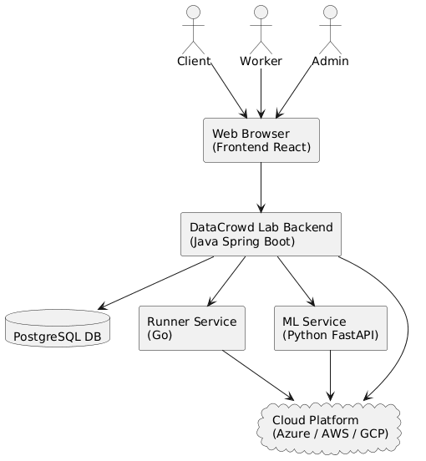

4.2 Architecture and Integration
The architecture of DataCrowd Lab is broken into logical layers and physical components that work together. Key diagrams are presented in this section to illustrate different views of the system’s design.
Logical Architecture: This view focuses on the internal structure of the system and how different software modules interact. The platform follows a layered approach with distinct concerns separated: front-end vs back-end, and within the back-end, different modules handle different domains (authentication, analytics, etc.).
Figure 4.2: Logical Architecture – The internal high-level design of the DataCrowd Lab platform. The front-end (React Single Page Application) communicates with a REST API exposed by the back-end. The back-end (Java Spring Boot) is modular, comprising an API Gateway that routes requests to appropriate modules/services. Shown here are an Auth Module responsible for user authentication/authorization and an Analytics Module for computing project stats and insights. These could be separate microservices or logical modules within the back-end. The diagram shows how the front-end calls the API, which hits the gateway/back-end, and how the back-end is structured into sub-components that handle specific functionality.
In this logical view, Auth Module handles login, signup, roles, etc., ensuring secure access (only Admins can create projects, etc.). The Analytics Module might handle computing progress (e.g., percentage of tasks completed, average agreement rate) and provide data for the dashboard. The API Gateway/back-end orchestrates calls to the database or other services as needed. For example, when a contributor submits a task, the back-end’s task controller would validate the submission (Auth Module might verify the user’s session), then save to DB and maybe call Analytics to update metrics.
High-Level Microservice Component Diagram: While the logical architecture shows modules, this component diagram shows the deployment of distinct services (microservices) and their interactions, including data storage. It highlights the separation of the system into independently deployable units and how they communicate.
Figure 4.3: High-Level Microservice Component Diagram – This diagram depicts the major services of DataCrowd Lab and their interactions. The Frontend (React SPA served to web browsers) communicates with the Backend API Service (Spring Boot) over HTTP/REST. The Backend service interacts with the Runner Service (Go) – for instance, to trigger background processing – and all services that need persistence use the PostgreSQL Database. In this diagram, the arrows indicate communication paths: e.g., the Backend API reads/writes to the database (for storing projects, tasks, etc.), the Runner Service might also access the database or get instructions from the Backend. A possible Machine Learning Service (not fully detailed if not implemented) would similarly connect to the Backend or Runner. This diagram emphasizes that each major component (frontend, backend, runner, DB) is containerized and interacts through network calls.
In this microservice setup, each service can be containerized and scaled. The backend might call the Runner Service via an HTTP API or message queue to perform tasks like generating additional data or running validations asynchronously. The database is a single source of truth for data; all writes (like storing a task result) happen through the backend, ensuring business rules are enforced in one place. The Runner and ML services, if they need data, either get it via the backend or have controlled direct access to specific tables (depending on design). The diagram shows Docker icons, indicating we plan to use containerization (as detailed in Deployment below).
Deployment Diagram: The deployment view shows how the system is hosted in development and production environments. We use Docker for containerization and target cloud deployment for the live system.
Figure 4.4: Deployment Diagram – This diagram outlines how DataCrowd Lab is deployed from development to cloud. On a Developer’s Machine, Docker Compose is used to run all components (Frontend, Backend, Runner, ML, and a PostgreSQL container) together for easy testing. In the Cloud Environment (e.g., Azure or AWS), each service is deployed in a container. The diagram suggests using an App Service or VM to host the containers (for instance, using Azure App Service for Containers or AWS EC2 instances). The Frontend (React app) might be served via a static web service or CDN. The Backend and other services run as Docker containers in the cloud, and a cloud database instance (managed PostgreSQL) is used. CI/CD pipelines would take Docker images from the dev environment and deploy them to the cloud. The “Docker Compose” mention under Developer Machine indicates how all services are orchestrated locally for development convenience[5]. In production, a more scalable orchestration (Kubernetes or Azure Container Apps) could be used, but for the scope of this project an App Service or simple VM is chosen.
The deployment diagram also highlights separation of environments: developers test everything locally with one command (thanks to Docker Compose including all microservices and the database in a single configuration). This ensures that if it works on the developer’s machine, it will work similarly in the containerized cloud environment, addressing the “works on my machine” problem[6][5]. In the cloud, using Azure or AWS, the containers can be deployed in a group. Azure, for example, could use Azure Container Instances or Azure App Service for each container. We assume a relatively straightforward deployment where each microservice is a container behind a common network or API gateway. Security groups and environment configuration will ensure the services can talk to each other (e.g., backend knows the DB connection string, etc.).
Integration considerations between components: All services use standard protocols (HTTP for service API calls, JDBC for database). The front-end integrates with back-end via AJAX calls (fetch/XHR). The system integration has been designed such that swapping out one component (say, using a different ML service implementation) is feasible as long as it adheres to the API contract. The architecture and integration approach prioritize loose coupling and clear interfaces.

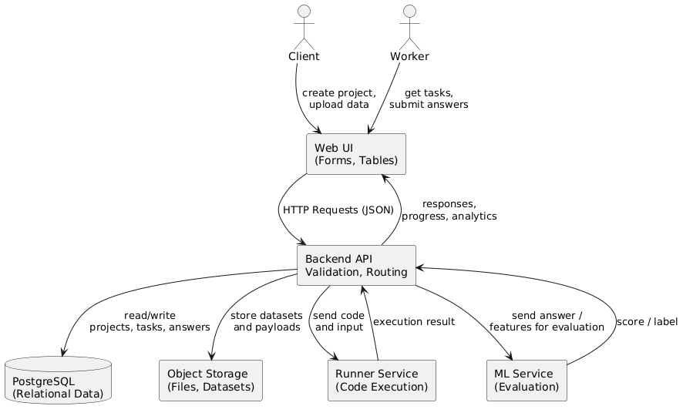
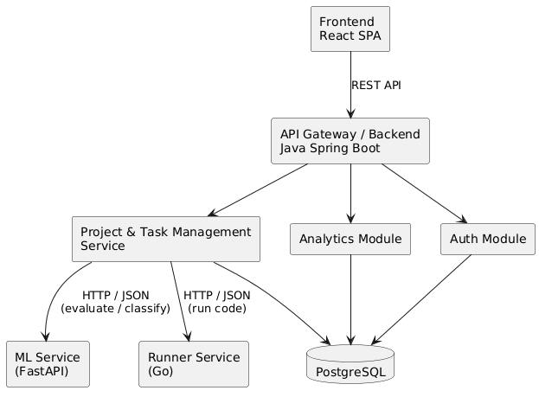

4.3 Alternatives Considered
In designing DataCrowd Lab, we considered several alternative approaches for both architecture and implementation. Here we document the major alternatives and why the chosen solution was preferred:
- Monolithic Application vs. Microservices: One alternative was to build the entire system as a single monolithic application (for example, include all functionality in the Spring Boot back-end, and not have separate runner or ML services). This would simplify deployment (just one service to run) and might be easier to develop initially. However, we opted for a microservice-oriented design to better separate concerns and allow independent scaling. Given that certain tasks (like potential ML processing or long-running data prep) should not block the main web application, having a Runner service is architecturally cleaner. The microservice approach also aligns with modern practices and provides a learning opportunity in the diploma context. The trade-off is added complexity in orchestrating multiple services, but the benefits in modularity were deemed more important.
- Using an Existing Crowdsourcing Platform or Library: Instead of building from scratch, we considered leveraging existing platforms or APIs (for instance, Amazon Mechanical Turk’s API or open-source crowdsourcing frameworks) to handle the task distribution. This could have saved development time on core features. We decided against it because the project’s goal is to create an independent platform tailored to our specific vision (including integration with an ML component). Relying on an external platform would limit customization and learning. Moreover, existing platforms often require payment and have their own constraints that didn’t align with our academic scenario.
- Technology Stack Choices: Alternatives for each layer were considered. For the front-end, we considered Angular or Vue.js as alternatives to React. React was chosen due to familiarity and its strong ecosystem for single-page apps. For the back-end, we considered Python (Django/Flask) or Node.js. We went with Java Spring Boot because it is robust, well-known for enterprise applications, and provides out-of-the-box features for building REST APIs quickly. Spring’s security and integration capabilities were a plus for implementing auth and connecting to a SQL database. The Runner Service in Go was an interesting choice – alternatives included using Python for that as well. Go was selected for its performance and efficiency with concurrent tasks, which suits the idea of orchestrating or running background jobs. Also, using Go demonstrates polyglot microservices. However, this introduced the alternative consideration: we could have implemented runner functionality as just another thread in the Spring Boot app (again a monolithic approach). We chose the separate Go service to practice true microservice separation and to avoid any heavy job from impacting the Java process.
- Database Alternatives: We briefly considered NoSQL databases (like MongoDB) especially for storing unstructured results or if flexibility was needed. However, since our data model (users, projects, tasks, answers) is quite relational and structured, PostgreSQL (a relational DB) was the better fit. It ensures data integrity (we can use foreign keys to link tasks to projects, answers to tasks, etc.) and it’s something the team had experience with. PostgreSQL’s reliability and ACID compliance were prioritized over the schema-flexibility of NoSQL, which we didn’t actually require for this domain.
- Quality Control Approach: For ensuring result quality, alternatives ranged from algorithmic methods to manual review. We considered implementing an automated machine learning-based checker (for example, training a quick model to predict if an answer is outlier). This was deemed too complex for the initial scope. Instead, we settled on simpler alternatives: redundancy (assigning tasks to multiple workers) and majority vote or admin review for disputed cases. This human-centric method is simpler and reliable, if somewhat less automated. It fits the timeframe and is a known practice in crowdsourcing to improve quality.
- Hosting and Deployment Options: The deployment approach chosen was containers on a cloud VM/App Service. An alternative was to use a fully managed Kubernetes cluster (like Azure Kubernetes Service or AWS EKS) from the start. That would be more scalable and closer to a production-grade solution for microservices. However, managing Kubernetes within the project scope was too time-intensive and overkill for the expected load. We opted for a simpler alternative (Docker Compose for dev, then maybe docker-run on a VM for prod). This meets our needs without the overhead of cluster management. Another alternative considered was to deploy the backend on a serverless platform (Azure Functions or AWS Lambda) to handle tasks on-demand and a static site for frontend. This was not chosen due to complexity in converting a stateful multi-endpoint service into many serverless functions, and because maintaining WebSocket or long-poll for tasks would be harder. Containers gave us more control and simplicity in this context.
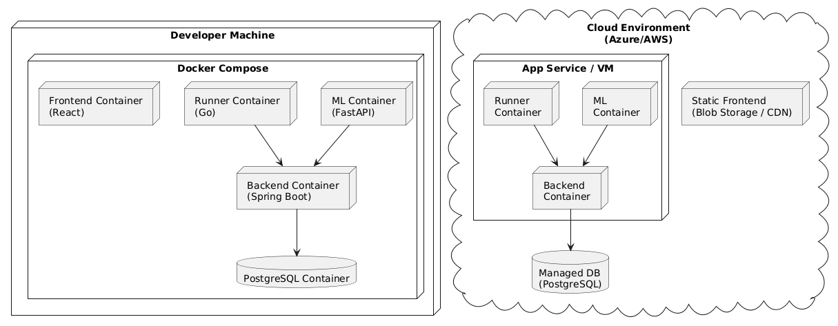
Each alternative had pros and cons, but the decisions made were aligned with the project’s goals, resource constraints, and the desire to demonstrate certain technologies. We aimed for a solution that is modern, yet feasible to implement and understand within the diploma project scope.

5. Features & Requirements

5.1 Core Features
DataCrowd Lab comprises several core features that together deliver the intended functionality. Below is a summary of the primary features:
- User Registration & Login: New users (admins or contributors) can create accounts and authenticate. This includes a simple registration form and a login mechanism. User roles (admin or contributor) are either assigned by the system or configurable by an admin. Secure password handling (hashing) and session management are implemented.
- Project Creation: Authenticated Admin users can create a project by providing a title, description/instructions for the task, and uploading the dataset (or data file) that needs to be broken into tasks. For example, if the task is to label images, the admin can upload a zip of images or list of image URLs. The system will register this project and prepare tasks.
- Task Generation: Once a project is created, the system automatically generates individual tasks from the dataset. Each task is a small unit of work (e.g., one image to label, one text entry to verify). This feature may involve the Runner service if needed (for example, if the dataset needs preprocessing). Tasks are stored with status “open” initially.
- Task Assignment (Crowd Marketplace): An interface for contributors to browse available projects and tasks. Contributors can select a project they are interested in and the system will provide them with an available task (ensuring no two contributors work on the same task simultaneously if only one response is needed, or limiting concurrency if multiple responses are needed). Essentially, this acts like a mini marketplace where tasks are listed under each project.
- Task Execution & Submission: The core feature for contributors: a task view page where the item is presented (e.g., show the image or text) along with a way to input their response (could be multiple-choice, text field, bounding box drawing, etc., depending on task type). The contributor completes the task by providing the requested annotation/answer and submits. The system records the answer and confirms completion, then can either give another task or allow them to pick another project.
- Project Monitoring Dashboard: Admins can view the progress of their projects through a dashboard. This feature shows metrics like number of tasks completed vs total, how many contributors have participated, average agreement rate (if tasks have multiple submissions), etc. Admins can also drill down to see individual task results or flag tasks for review if needed. Basic visualizations or summary statistics are part of this feature to give a quick overview.
- Quality Assurance Workflow: A set of sub-features dedicated to quality: the ability for admins to configure that each task requires multiple independent answers for redundancy, highlighting tasks with conflicting answers (majority vs minority answers), and allowing admins or designated reviewers to resolve those conflicts. Also, potentially, a way to ban or filter out low-performing contributors (for example, if a contributor’s answers frequently conflict with others, an admin might be alerted).
- Notifications: Simple notification mechanisms are included, such as notifying an admin when their project is complete (all tasks done), or notifying contributors of new projects available. This could be via email or an in-app notification list. This feature is to keep users engaged and informed without them having to constantly check manually.
- Data Export: Admins can export the results of their projects (the collected annotations) in a usable format (CSV, JSON). This feature ensures that after completion, the data can be downloaded for use outside the platform (for training AI models, etc.).
- Administration & Settings: A feature set for the platform admin (system administrator) to manage the system, e.g., user management (activate/deactivate users), viewing all projects in the system, and possibly system settings (like turning the platform maintenance mode on/off). This ensures the platform can be maintained over time.
These core features are designed to work in concert: for example, user auth is a prerequisite to project creation, which leads to task distribution, which then relies on task execution and quality control, and finally results in data export and insights.
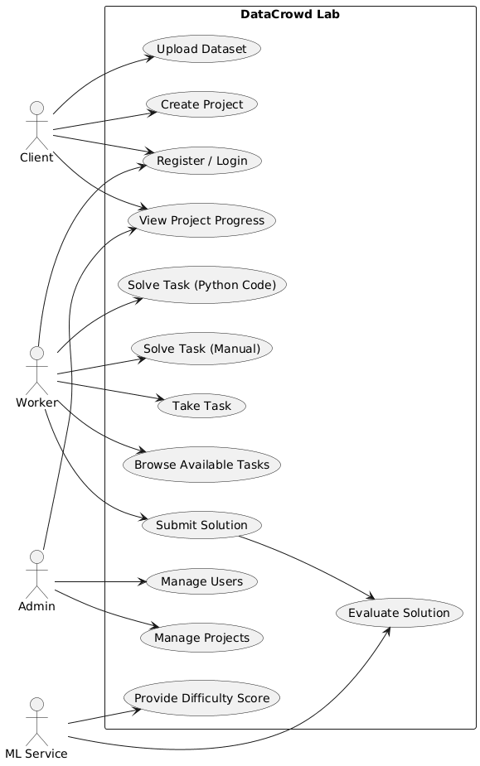

5.2 Functional Requirements
This section details the functional requirements of DataCrowd Lab, often expressed as user stories with acceptance criteria, for both Admins and Contributors. These requirements describe how the system should behave and what capabilities it must provide.

User Stories and Requirements for Admin (Project Owner) Role:
- FR1: Account Creation (Admin)
User Story: As a potential project owner, I want to sign up for an account so that I can create and manage annotation projects on the platform.
Acceptance Criteria:
- The system shall allow a new user to register with a unique email and password. Optionally, the user can specify if they are signing up as an Admin or Contributor (or this can be granted later by an existing admin).
- Confirmation message or email is sent after successful registration.
- The password must meet minimum complexity rules (e.g., 8+ characters, mix of letters/numbers).
- The system shall prevent duplicate registrations with the same email.
- FR2: Login and Authentication
User Story: As an authenticated user (admin or contributor), I want to securely log into the platform so that I can access features according to my role.
Acceptance Criteria:
- The system shall provide a login form where users enter email/username and password.
- If credentials are correct, the user is granted a session (or JWT token for the SPA) and redirected to their dashboard page.
- If credentials are incorrect, an error message is shown, and access is denied.
- Passwords are not stored in plain text (they are hashed in the database).
- Sessions/tokens expire after a certain period of inactivity for security.
- FR3: Create Project
User Story: As an Admin, I want to create a new project with a dataset so that I can begin a crowdsourcing job.
Acceptance Criteria:
- There shall be a “Create Project” form where admin enters project title, description/instructions for contributors, and uploads the dataset or data file(s).
- The system shall support dataset upload of certain types (e.g., CSV file containing items, or a ZIP of images). The upload size might be limited by configuration.
- After submission, the project is saved in the database with status “Active” and tasks are generated (FR4).
- The UI confirms project creation and displays the project details page to the admin (with initial stats like 0 tasks completed out of N).
- FR4: Task Generation from Dataset
System Requirement: Once a project is created, the system must generate individual tasks for contributors.
Acceptance Criteria:
- The system shall parse the uploaded dataset. For example, if a CSV is provided, each row could be a task (or each item in JSON, or each image in a ZIP).
- Each task record includes reference to the data (e.g., a path to an image or the text snippet) and is linked to the project.
- Tasks are marked “Open” (available for assignment) initially.
- The number of tasks generated equals the number of data items. If an error occurs in parsing, the system shall log it and inform the admin of any issues (e.g., “10 tasks created, 2 data items could not be processed”).
- (If using Runner Service for this) The back-end shall call the Runner to process complex dataset files. The Runner returns a list of tasks or confirms completion.
- FR5: View Project Dashboard
User Story: As an Admin, I want to see the status of my project (tasks and contributions) so that I can monitor progress and quality.
Acceptance Criteria:
- The system shall provide a project dashboard page accessible only to the project’s admin.
- It shall display: total number of tasks, number of tasks completed, number of unique contributors who worked on it, and overall completion percentage.
- It shall display quality info: if multiple responses per task, show the agreement rate or how many tasks have conflicting answers requiring review.
- Admin can click to view task details (FR6) and review answers if needed.
- The dashboard auto-updates or provides a refresh option to get latest stats as contributors work.
- FR6: Review Task Results
User Story: As an Admin, I want to review the answers given by contributors for each task, so that I can validate them or resolve any conflicts.
Acceptance Criteria:
- Admin shall be able to view a list of tasks and their submitted answers. For each task, show what the item was (e.g., display the image or text) and all answers submitted (and by whom, if needed).
- If a task has multiple answers that differ, highlight it (e.g., in red) as needing attention.
- Admin can mark a certain answer as the accepted ground truth (or provide their own correct answer) for tasks that had conflicts or to finalize them.
- The system records any admin overrides or validations (could mark the task as “Verified”).
- (Optional) Provide a way for admin to send feedback or simple rating for contributors’ answers, but this might be out-of-scope unless used for a reputation system.
- FR7: Export Results
User Story: As an Admin, I want to export the aggregated task results once my project is done, so that I can use the data for research or model training.
Acceptance Criteria:
- On the project dashboard, if the project is complete (or even during progress), admin can click “Export” to download results.
- The export should compile each task’s data item and the final answer. If multiple contributors answered each task, the final answer could be a majority vote or the admin-validated one (as per FR6).
- Export format options: CSV (e.g., columns for item ID, item content, answer) or JSON. At least one format (CSV) is required.
- The system should handle escaping or formatting so that the data is intact (e.g., if answers contain commas, properly quote in CSV).
- A confirmation is shown after export (or it triggers a file download in the browser).
- FR8: Manage Contributors (Admin)
User Story: As a Platform Admin (system administrator), I want to manage user accounts and their roles, so that the platform remains secure and organized.
Acceptance Criteria:
- There shall be an admin panel accessible only to platform administrators (not regular project admins, unless in this system they are the same – clarify roles: possibly there’s a super-admin role for platform maintenance).
- The panel lists all users, with ability to deactivate/reactivate accounts, or upgrade a contributor to an admin role (if we want to allow more project owners).
- The system shall ensure that critical actions (like deleting a user or project) have a confirmation step.
- Auditing: It should log actions like user role changes or deletions for security purposes (could be simple logs).
- (This is a platform maintenance feature and ensures smooth operation long-term but might have lower priority if focusing on core usage first.)

User Stories and Requirements for Contributor (Worker) Role:
- FR9: Browse Projects (Contributor)
User Story: As a Contributor, I want to see a list of available projects and understand what tasks they involve, so I can decide where to contribute.
Acceptance Criteria:
- After login, a contributor is presented with a dashboard listing active projects that need work. For each project, display key info: title, brief description, how many tasks are open, maybe how many already completed.
- The contributor can click on a project to see more details (instructions provided by admin, etc.).
- Projects that are 100% completed might be hidden or marked as closed so contributors focus on active ones.
- If a project has qualifications (not in current scope, but e.g., only certain users can do it), those not qualified either don’t see it or see a lock icon. (Assume open to all in this scope.)
- FR10: Claim Task & Perform Task
User Story: As a Contributor, I want the system to give me an available task from a project I choose, so that I can work on it immediately without confusion with other workers.
Acceptance Criteria:
- When a contributor clicks “Start” or “Work on Project X”, the system retrieves one open task from that project and assigns it to the contributor (at least temporarily while they work on it).
- The task view is shown: it includes the task content (e.g., image displayed or text shown) and the input controls needed for the answer (could be a text box if labeling an image with a tag, or multiple choice if predefined answers, etc.).
- The system should lock the task for that contributor while it’s being worked on, to avoid multiple people doing the exact same task at the same moment (unless redundancy is desired – in which case tasks can still be served multiple times but track each separate assignment).
- If the contributor decides to skip or cannot do it, there should be an option to release the task (so it goes back to open status for someone else) – or we encourage them to submit something.
- The UI shows any specific instructions or criteria for that task (e.g., “Choose the best label for this image from [cat, dog, other]”).
- FR11: Submit Task Answer
User Story: As a Contributor, I want to submit my answer for the given task and receive confirmation, so that I can move on to another task.
Acceptance Criteria:
- When the contributor inputs their answer and clicks “Submit,” the system shall send this answer to the back-end.
- The back-end saves the answer (with attribution to the contributor and timestamp). The task is marked accordingly: if only one answer needed, mark it complete; if multiple needed, mark one submission received.
- The UI should display a confirmation like “Your answer has been submitted. Thank you!” and then offer the next step: e.g., a “Next Task” button to immediately load another task in the same project, or an option to return to project list.
- The system should handle errors (e.g., if network fails). If submission fails, user is informed to retry. Duplicate submissions of the same task by the same user should be prevented (e.g., disable double-click or handle idempotently).
- If the project requires multiple annotations, the contributor might be allowed to do another task rather than the same one again, unless we are intentionally collecting multiple answers from different people.
- FR12: Task Interface Usability
Requirement: The task interface should be tailored to the task type for efficiency and clarity.
Acceptance Criteria:
- If the task is image labeling, the image is displayed clearly and any selection inputs (dropdown, radio buttons for categories, etc.) are easy to use.
- If the task is text, the text is shown in a readable format (proper text wrapping, maybe highlighting key parts if needed).
- The interface should prevent submission if mandatory input is missing (e.g., require at least one option to be selected).
- There should be a way to exit or pause: e.g., a contributor can navigate away from a task if needed (possibly that abandons the task back to open pool after some time-out).
- Consider keyboard shortcuts for faster workflow if possible (not required but a nice-to-have: e.g., press 1/2/3 for choosing option A/B/C).
- FR13: View Personal Contribution History
User Story: As a Contributor, I want to see what tasks I have completed and possibly any feedback, so that I can track my contributions.
Acceptance Criteria:
- The system provides a simple history page for the contributor listing tasks they’ve done (could be grouped by project).
- For each, show status if the task was accepted or if an admin overrode it (this may be advanced, but if an admin marked their answer as incorrect in review, it could be shown).
- Possibly show summary stats: total tasks completed by that contributor, maybe an accuracy score if applicable (like if their answers match others’ often).
- This feature motivates contributors and also allows them to verify their work is accounted for. If any tasks are pending (like waiting for other reviewers), that could be indicated.
- The system shall ensure that contributors cannot see others’ answers here – only their own and any evaluation of them, to maintain confidentiality and fairness.
The functional requirements above ensure that both primary user groups (Admins and Contributors) can achieve their objectives on the platform. The behavior described aligns with the core features and will be further refined in design and implementation.
Figure 5.1: Use Case Diagram – This diagram illustrates the primary actors (Admin and Contributor) and their interactions (use cases) with the DataCrowd Lab system. The Admin actor has use cases such as “Create Project,” “Manage Tasks/Review Results,” and “View Project Analytics.” The Contributor actor has use cases like “Browse Projects,” “Complete Task,” and “View Own Stats.” Both actors share the “Authenticate User” use case (log in/out). This diagram provides a high-level summary of system functionality from the users’ perspective.
In the use case diagram (Fig 5.1), we see the Admin can perform project-related actions (enclosed within the “DataCrowd Lab” system boundary), and the Contributor engages in task-related actions. This ensures all the functional requirements enumerated are accounted for by at least one use case in the diagram.
Figure 5.2: Activity Diagram – This diagram shows the workflow for a Contributor performing tasks in a project. It begins with the Contributor logging in, then selecting a project, browsing for an available task, and a decision point “Task available?”. If yes, the Contributor takes the task, performs the required work, and submits the result. If no tasks are available (project completed), the flow might loop to let them choose another project or end. This activity flow emphasizes the typical sequence of actions and decisions a contributor goes through on the platform.
The activity diagram (Fig 5.2) highlights the real-time process for contributors: after login, they continuously cycle through selecting projects and completing tasks until no work remains. It also implicitly involves system actions like assigning a task when one is available.
Figure 5.3: Sequence Diagram – This diagram illustrates the interactions for the “Create Project and Task Distribution” scenario. In this sequence: an Admin user interacts with the Frontend (Browser) to create a project. The Frontend calls the Backend API (“createProject” request), the Backend processes it (perhaps storing project info in the DB and invoking the Runner Service to generate tasks). The Runner Service reads the dataset and inserts task entries into the PostgreSQL database (or returns them to Backend to insert). Once tasks are ready, the Backend responds to Frontend confirming project creation. Later, a Contributor’s browser requests a task (e.g., “getNextTask”), the Backend queries PostgreSQL for an open task, returns it to the Contributor, who then submits an answer (“submitTaskResult”). The Backend saves the result (update DB) and possibly notifies the Analytics module or updates metrics. The sequence ends with the Contributor receiving confirmation of submission. This diagram shows how different components (Frontend, Backend, Services, DB) collaborate to fulfill a user action.
The sequence diagram (Fig 5.3) ties together many functional requirements, demonstrating the end-to-end flow for two key scenarios (admin project setup and contributor task completion). It ensures that the roles of each component defined in the architecture align with fulfilling the functional needs (e.g., the Backend orchestrates between UI, DB, and Runner service as required).

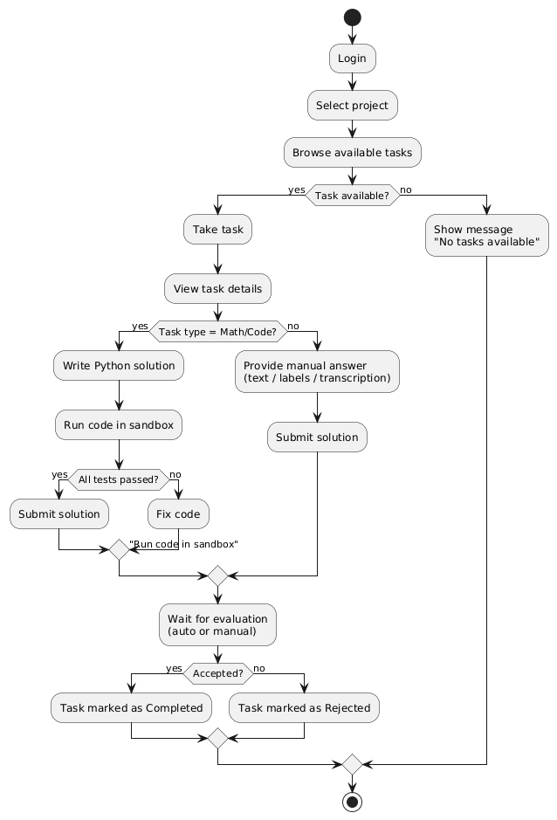
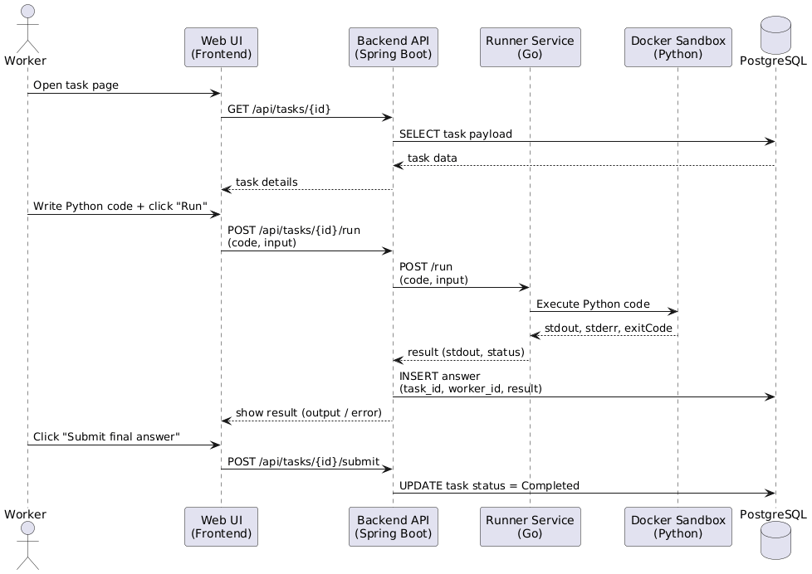

5.3 Non-Functional Requirements
In addition to functional capabilities, DataCrowd Lab must meet various non-functional requirements (NFRs) that ensure the system’s usability, reliability, and performance. Below are the key NFRs:
- NFR1: Usability and UI/UX – The platform should be intuitive and easy to use for both admins and contributors. This means a clean UI design with clear navigation (e.g., dashboards for each role). Pages should have instructions or help text where appropriate (for example, contributors should see instructions on how to perform the task). Usability will be measured by feedback from initial users and observing that new users can perform key tasks (like completing an annotation) without extensive training. Shortcuts and streamlining (like bulk upload for data, one-click for next task) should be implemented to reduce user effort.
- NFR2: Performance – The system should handle concurrent usage within expected load. As a baseline, the system (back-end and database) should support at least 50 concurrent contributors submitting tasks without significant slowdowns. Typical page/API response times should be under 2 seconds, and task submission processing under 1 second (not counting any very heavy ML jobs, which would be asynchronous). The front-end should load the main app and project data within, say, 3 seconds on a standard connection. We will also ensure the platform can scale vertically (e.g., a better server can improve throughput) or horizontally (running multiple service instances behind a load balancer) when needed, though horizontal scaling might be limited by our chosen deployment method initially.
- NFR3: Reliability and Availability – The platform should be reliable: uptime target is 99% during active periods (accounting for development environment, but in production, aim for minimal downtime). Key reliability features include: the system should not lose data (transactions like task submissions are committed to the database transactionally), and it should recover gracefully from minor failures. For example, if the Runner service crashes, the rest of the system continues to function for front-end operations, and the Runner can be restarted to resume background processing. We will implement basic health checks (e.g., a heartbeat endpoint for services) to monitor system health. Error handling is important – any error in processing a task or saving to DB should log and return a meaningful error to the user rather than failing silently or crashing.
- NFR4: Security – DataCrowd Lab will implement standard security practices. All communications between front-end and back-end should be over HTTPS (especially important if deployed online). Authentication is required for any non-public page, and authorization rules are enforced on the back-end (so contributors cannot call admin APIs and vice versa). Passwords will be hashed (e.g., using bcrypt or Spring Security’s recommended encoder) and never stored in plain text. There will be protection against common web vulnerabilities: sanitize inputs to prevent SQL injection (ORM use helps with this), use proper output encoding to prevent XSS in any dynamically shown content (like project descriptions), and implement CSRF protection for form submissions or use tokens in SPA context. Since this is not a publicly monetized platform, the risk profile is moderate, but we still ensure that one user cannot access another’s data (multi-tenancy separation by checking ownership on queries, etc.).
- NFR5: Maintainability and Extensibility – The system should be built in a modular way, making it maintainable and open to future extension. Following good coding standards and project structure is part of this (clear separation of layers: UI, API, service logic, data access). Use of meaningful naming, documentation in code, and possibly some automated tests are expected to aid maintainability. Extensibility examples: it should be relatively easy to add a new type of task (e.g., if we later want to support image segmentation tasks in addition to classification) by plugging into the existing framework, rather than rewriting core logic. The microservice architecture already helps by isolating components that could be replaced or upgraded (for instance, swapping out the ML service with a more advanced one later should not require changes to front-end, only to the API integration). Maintainability will also be measured by how easily a new developer (or the author in the future) can re-read and update the code—so clarity is key.
- NFR6: Scalability – While the immediate use might be limited, the design should not inherently prevent scaling to more users or tasks. This means the system should work with thousands of tasks and many concurrent contributors in principle. Using a robust database like PostgreSQL ensures we can handle large datasets (with proper indexing on task status, etc., queries remain efficient). The stateless nature of the back-end API (no in-memory session state besides tokens) allows running multiple instances behind load balancing if needed. We may not implement auto-scaling in the scope of the diploma project, but we won’t design ourselves into a corner that forbids it. Vertical scaling (bigger machine) should instantly allow more throughput if needed, and horizontal scaling (multiple containers) would be possible with minor configuration (sticky sessions or centralized session store if needed for login tokens, or using JWT which needs no server session).
- NFR7: Compatibility – The web application should be compatible with modern browsers (Chrome, Firefox, Edge, Safari) and degrade gracefully on older versions. Since it’s a web SPA, it should also be reasonably accessible on various screen sizes (desktop, tablets, mobile browsers) – responsiveness is considered (maybe using a CSS framework or media queries to adjust layout for smaller screens). We assume most contributors have at least a standard web browser. We will also ensure our tech choices are cross-platform on the server side (Docker ensures it runs on Linux servers in cloud same as on development machine). If any specific environment needs to be considered (like the university’s servers run Windows), our stack (Java, Go, Node for React build) is cross-OS, so it should not be an issue.
- NFR8: Privacy – Although no sensitive personal data is heavily used, we ensure basic privacy. User information (name, email) is only visible to themselves and platform admins (regular contributors won’t see each other’s emails, for example). Project data uploaded by admins is only accessible to contributors as needed for the task (and not downloadable in bulk unless via the intended export by admin). All user-generated data (like answers, or project content) is stored securely in the DB and not exposed outside the platform except through exports by authorized admins. If the project uses any 3rd party services, we ensure compliance with their privacy terms (e.g., if images are stored on a cloud storage bucket, we don’t inadvertently make it public). These measures align with ethical handling of data even if formal GDPR compliance is outside scope.
- NFR9: Testability – The system’s components should be built in a way that allows for testing. For instance, the business logic in the backend (Spring Boot) will have service classes that can be unit tested independently of the web layer. We plan to create some unit tests for critical functions (like task allocation algorithm, or data parsing). Integration testing can be done on a staging instance with sample data to ensure the end-to-end flow works (e.g., simulate an admin creating a project and a contributor doing tasks, and verify the counts match at the end). This is more an internal quality requirement, but it ensures that as changes are made, we can verify we haven’t broken key functionality. In a diploma project, demonstrating test cases also shows the system meets requirements consistently.
By meeting these non-functional requirements, DataCrowd Lab will not only have the features needed but will also provide a smooth, trustworthy, and robust experience. Many of these NFRs (like performance, security) will be evaluated during testing and user feedback phases.

5.4 Regulatory/Compliance Needs
Given that DataCrowd Lab is an academic project and an internal platform, regulatory and compliance considerations are relatively limited. However, we still address some key areas:
- Data Protection and Privacy Laws: If any personal data is stored (like user emails, names), we should consider general principles of data protection. For instance, the platform should have a privacy policy if it were public, but for our purposes, documenting how data is used is sufficient. We won’t use personal data beyond login and internal identification. In the spirit of regulations like GDPR, if a user (especially a contributor) wanted their data removed, we should be able to delete their account and associated personal info on request (this is an administrative function we could support manually). We won’t expose user personal data to others without consent. Since all data is user-provided and project-related, and presumably not sensitive personal information, we comply broadly with privacy best practices.
- Intellectual Property and Licensing: Projects may involve datasets that have their own licensing (for example, an admin might upload images that are copyrighted or confidential). It should be made clear (perhaps in the project description or a general terms of use) that contributors should not share the data outside the platform, and that all results (annotations) are property of the project owner. In an academic setting, this might not be strictly formal, but it’s good to note. From the platform side, our software uses open-source components (React, Spring, etc.) which are under permissive licenses (MIT, Apache) which we comply with by not restricting their usage and acknowledging them if needed in documentation.
- Accessibility Compliance: While not a law per se unless this were a public service, it’s good practice to consider accessibility (e.g., WCAG guidelines). For example, ensure the UI has proper labels on forms for screen readers, color choices have sufficient contrast, and keyboard navigation works. This is especially relevant if we assume a diverse contributor pool, including those who might rely on assistive tech. We’ll try to adhere to basic accessibility standards (such as alt text on images, ARIA labels for custom controls, etc.).
- Labor Regulations: If we were paying crowd workers, there might be labor law implications (minimum wage, etc.), but since our platform doesn’t handle payments or an employment relationship (likely voluntary or academic participation), we avoid those complexities. However, ethically, we ensure that the workload expected from contributors is reasonable and that they are treated fairly (e.g., credited or recognized if appropriate, and not overburdened).
- Academic Integrity: Since this is a diploma project, compliance includes adhering to academic standards in software development (no plagiarism in code, using properly licensed libraries, citing any external ideas or templates in documentation). We must produce original work or properly attribute any borrowed components.
- Security Standards: While not a regulation, we align with OWASP best practices for web security. If this were an enterprise setting, one might require compliance with certain security audits or standards (like ISO 27001 for information security). In our context, demonstrating awareness of OWASP Top 10 vulnerabilities and mitigating them is a proxy for compliance with industry security standards. For example, we will ensure compliance with OWASP recommendations like using secure password storage, protecting against injection attacks, using HTTPS, etc.
- Cloud Service Terms: If deploying on cloud services (Azure/AWS free tier), we must abide by their terms of service. Typically, this means not using the service for illegal activities, not exceeding free tier in ways that violate fair use, etc. DataCrowd Lab’s usage (some compute, database storage of non-sensitive data) is well within normal use, so we are fine here.
Currently, no specialized compliance like HIPAA (health data) or FERPA (education records) or COPPA (children’s data) applies, because we are not dealing with those types of regulated data. If in future the platform were used for say medical image annotation with patient data, then HIPAA would become relevant and we’d need to implement encryption, audit trails, etc. But that is outside our current scope.
In summary, DataCrowd Lab will conform to general data privacy principles, open-source licensing requirements, and security best practices. By doing so, we ensure that there are no legal or ethical obstacles to deploying and using the platform within our intended context.

5.5 Data Model (ER Diagram)
To support the features and requirements above, DataCrowd Lab relies on a well-structured data model. The core entities and their relationships are outlined in the Entity-Relationship (ER) diagram below, which represents how data is stored in the PostgreSQL database.
Figure 5.4: ER Diagram – This diagram shows the primary database entities for DataCrowd Lab and their relationships. Key entities include User, Project, Task, and Answer. The User entity stores user information (with attributes like userID (PK), username/email, passwordHash, role, etc.). The Project entity (with projectID as PK) is linked to a User (Admin) via a foreign key indicating which admin created it. Each Project has many Task entities (one-to-many relation; a taskID PK with a foreign key projectID). The Task holds the data item or reference for that item (e.g., image URL or text snippet) and status. The Answer (or Submission) entity records each contributor’s answer to a Task (answerID PK, FK to taskID, FK to userID for contributor). Attributes on Answer include the content of the answer and perhaps a flag for whether it’s accepted/validated. Additionally, there could be other tables not shown in snippet, like an Audit or Review table if admins’ reviews are stored, or a Session/Token table if needed for auth (though JWT might remove need for session table). This ER diagram ensures referential integrity: e.g., deleting a Project can cascade to its Tasks and Answers if allowed.
In the ER diagram, note the following relationships and design decisions:
- A User can be an Admin or Contributor (distinguished by a role field). An Admin may create multiple Projects, so the relationship from User to Project is one (user) to many (projects). If a user is deleted or demoted, we decide what happens to their projects – likely an admin wouldn’t be deleted unless transferring projects or archiving them.
- A Project contains many Tasks. Each Task is a unit of work. Tasks have fields such as description (or a pointer to the actual item, like a file path or URL), a status (open, in-progress, completed), and maybe a difficulty or type field if needed.
- A Task can have multiple Answers (submissions) associated, especially if we allow multiple contributors to answer the same task for quality control. Each Answer links to the Task and to the User who submitted it, and has the actual answer content (which might be text, numeric, or a reference depending on type). If tasks can only have one answer, we would integrate Answer into Task as fields, but since we foresee multiple answers (and for many-to-one relation), a separate Answer entity is cleaner.
- Potential additional relations: If we had a review process, an Answer might have a field like “validated_by_admin” or an Admin could have a separate Review entry. For simplicity, we might just update an Answer’s status if an admin approves or rejects it.
- Relationships cardinality: The diagram shows (in notation form) that:
- One User (Admin) to many Projects.
- One Project to many Tasks.
- One Task to many Answers (submissions).
- Also, one User (Contributor) to many Answers (i.e., a contributor can submit many answers across tasks/projects).
- The database schema will enforce these with foreign keys. For example, Answer.userID references User.userID, Answer.taskID references Task.taskID, Task.projectID references Project.projectID, and Project.adminUserID references User.userID (the admin who owns it).
- There might be a separate mapping if needed: e.g., if we allowed multiple admins per project (maybe not in this scope, likely one project owner).
- The ER model ensures that if a Project is deleted, we might cascade delete tasks and answers to maintain consistency (or mark them orphaned which we likely avoid). This reinforces scope decisions (if we allow project deletion or not).
Having this data model helps in implementing the back-end. We can create tables corresponding to these entities. It also ensures that queries can be optimized (indexes on foreign keys like taskID, userID, etc.). For example, listing all open tasks for a project is a query on Task table filtering by projectID and status. Retrieving all answers a contributor gave is a query on Answer filtering by userID. The model is normalized enough to avoid duplication (answers separate from tasks, etc.). We also avoid storing large blobs in these tables directly; if an image file is uploaded, we might store a path or name, and the file might be on disk or cloud storage.
This ER diagram is a crucial blueprint for developers and also communicates to stakeholders that the data backbone of the system is well thought out, ensuring data consistency and supporting the functional requirements (like tracking who did what, and linking everything properly).

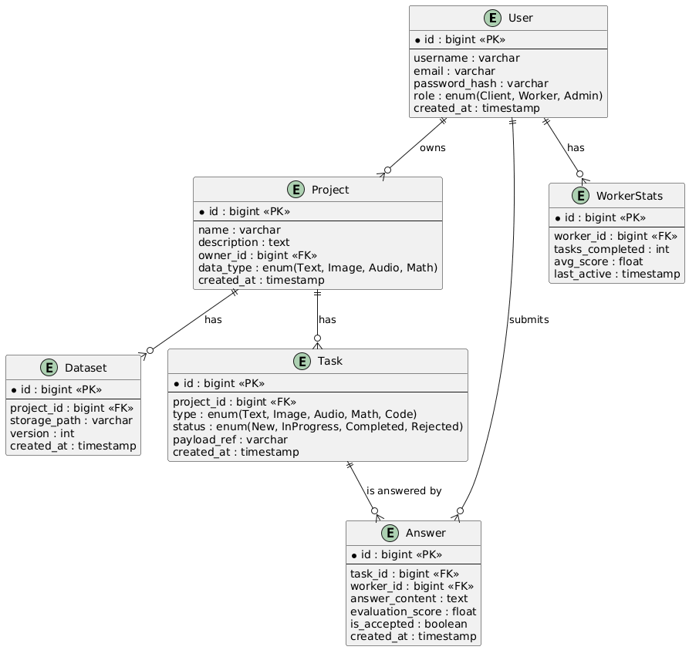

6. Risks & Dependencies

6.1 Risks and Mitigation Strategies
Implementing and deploying DataCrowd Lab comes with several risks. Below we identify the key risks and how we plan to mitigate them:
- Risk R1: Low Quality of Crowdsourced Data – There is a risk that the contributors’ submissions may be inaccurate or inconsistent, which would undermine the platform’s purpose. Likelihood: Moderate (common in any crowdsourcing). Impact: High on project success (output data might be unusable if quality is poor).
Mitigation: Employ quality control measures from the start. As described in requirements, we will collect multiple answers for critical tasks and use majority voting to filter out noise. We will also implement contributor guidelines and possibly simple qualification tasks at the beginning to train contributors on how to do the work properly. Additionally, tasks can be reviewed by the admin; a sample of early tasks could be double-checked to catch issues with instructions or misunderstandings. Over time, track contributor performance; if someone consistently provides bad answers, the system (or admin) can restrict their participation (perhaps via manual removal or automatic flagging). By having these control mechanisms, we aim to ensure that despite crowd variability, the final data quality remains acceptable[4].
- Risk R2: Insufficient Contributor Participation – The platform might launch but fail to attract enough contributors to complete the tasks in a timely manner. Likelihood: Moderate (depends on context, but in an academic environment, it might be manageable). Impact: Medium (projects get delayed or incomplete).
Mitigation: To mitigate this, we would engage potential users early. For a diploma project, this might mean recruiting classmates or online volunteers to try the platform as beta testers. Making the platform easy and maybe fun to use (through a clean UI and maybe showing contributors their stats or a leaderboard) can improve engagement. If needed, add minor incentives like digital certificates or acknowledgments for top contributors. On the project admin side, if participation is low, the admin might reduce scope (fewer tasks or simpler tasks). The risk is also less if this is used internally (like within a lab group) where participation can be organized. Clear communication of the project’s value to contributors (e.g., “Help annotate data for research and see the results”) can motivate involvement.
- Risk R3: Technical Integration Failures – With multiple components (React front-end, Spring Boot, Go service, ML, PostgreSQL), there is a risk that the integration doesn’t work as expected — e.g., API mismatches, Docker networking issues, etc. Likelihood: Moderate (especially if team members are new to some tech). Impact: Medium (delays in development, possibly reduced functionality if not resolved).
Mitigation: We plan extensive testing of each interface. For example, define and test the REST API endpoints early using tools like Postman or integration tests in Spring. Ensure that the Runner Service’s API (or however it’s triggered) is clearly defined and maybe start with a very simple job (like ping/pong) to test connectivity. Using Docker Compose in development will surface networking issues in a controlled environment that mimics production. We also have fallback plans: if the separate Runner or ML service integration proves too troublesome within time, the mitigation could be to fold essential parts directly into the backend (monolithic fallback) so that the project’s core functionality isn’t blocked. We document APIs and use consistent data formats (e.g., JSON structures) to avoid confusion. Essentially, start integration early and solve issues one by one rather than last minute.
- Risk R4: Delays in Project Timeline – Because this is a diploma project, time is of the essence. Unforeseen difficulties (like a harder-than-expected bug, or personal downtime) could cause delays, risking incomplete features by deadline. Likelihood: Moderate. Impact: High (could affect graduation timeline or require scope cuts).
Mitigation: We adopt an agile approach with iterative development. Prioritize core features (user auth, basic task flow) to be done first. That way, we have a working end-to-end prototype early. If time runs short, we can gracefully degrade by having the basics working even if some advanced features (like fancy analytics or polished UI elements) are missing. Regular check-ins with project supervisor can catch if we’re behind schedule and prompt adjustments. Another mitigation is scope buffer: identify “nice-to-have” features that can be dropped if needed (e.g., if absolutely needed, the separate ML integration could be simplified or presented as design-only rather than full implementation). By closely monitoring progress and adjusting workload, we aim to avoid last-minute crunch failure.
- Risk R5: Security Breach or Data Loss – There’s a risk of security vulnerabilities that could be exploited (especially if the app is accessible on the internet). Also, a misconfiguration could lead to data loss or leaks (like an open S3 bucket if we used one for datasets, etc.). Likelihood: Low to Moderate (since we’re taking measures, but never zero). Impact: Low to Medium for this project (data is not extremely sensitive, but a breach can damage credibility and require time to fix).
Mitigation: Follow best practices from day one: use prepared statements/ORM to prevent injection, validate user inputs, use HTTPS in deployment, and test for common issues (we can do a basic vulnerability scan or code review focusing on security). Keep the software dependencies updated to avoid known exploits. For data loss, we will take backups of the database especially before major changes. In development, use version control for code to not lose code. If deploying on cloud, enable any offered backup service for the DB if possible. Because our user base is small, we can monitor logs for any suspicious activity. Essentially, through proactive security design and maintenance, we mitigate breaches; through backups and careful configuration, we mitigate data loss.
- Risk R6: Cloud Service Limitations – Using free or low-tier cloud services might impose limits (on storage, CPU, etc.), which if exceeded could cause service disruption. For example, hitting the cap on database size or getting throttled for too many requests. Likelihood: Low (for a small-scale use, likely fine). Impact: Low (worst case, system becomes slow or temporarily down until limits reset).
Mitigation: We’ll estimate usage and choose services accordingly. The data we store (mostly text and numbers) is not huge for a prototype – likely under a few tens of MB for everything, which is fine. We’ll also test under expected load to ensure we aren’t near any obvious limits (like 20 connections if DB allows only 20, we manage pooling). If we approach a limit, we can upgrade to the next tier or find an alternative (maybe host DB locally for demo if needed). We’ll also build a simple monitoring – even a manual check on resource usage occasionally. Being mindful of cloud usage patterns (for example, avoid infinite loops in code that could generate huge costs inadvertently) is part of development.
Each risk above is tracked during the project. We will maintain a risk log and update mitigation actions as needed. For example, if during testing we find quality is low (Risk R1 manifesting), we might implement an extra feature such as an automated spam answer detector (e.g., flag if someone answers “asdf” for text tasks) to kick in as a mitigation.
By anticipating these risks and having clear mitigation strategies, we improve the chances of project success and smooth operation.

6.2 Dependencies
DataCrowd Lab depends on various external factors and components. These dependencies must function correctly for the platform to operate. Key dependencies include:
- Third-Party Libraries and Frameworks: We rely on numerous open-source libraries. For example, the React framework and its ecosystem (for the front-end), the Spring Boot framework and associated libraries (Spring Security, Spring Data JPA, etc.) for the back-end, and certain Go libraries for building the runner service. We depend on these to be stable and bug-free. If a critical bug or incompatibility in a library arises, it could hinder development. We mitigate this by using well-established versions (not bleeding edge releases) and have the option to patch or find workarounds if needed. We also need Node.js and npm for building the front-end; their proper installation and function are a dependency.
- Database Server: The system is dependent on PostgreSQL as the database. This means we rely on the DB server to be running, accessible, and properly configured (user accounts, schemas). In development, that’s a local Docker container – dependency is Docker itself and the image. In production, it’s maybe a cloud DB instance – dependency on cloud provider’s service. If the DB goes down, the platform essentially cannot function (no data retrieval or storage). To mitigate, ensure the database is configured to auto-start and has backups. The design also includes some resilience (the app should handle a DB connection loss gracefully by, say, showing an error and retrying until DB is back).
- Cloud Service Provider: If we deploy on Azure or AWS, we become dependent on that provider’s uptime and policies. For instance, using Azure App Service for containers means we rely on Azure’s infrastructure – any outage in the region or service will affect us. Similarly, if using AWS S3 for storing dataset files or any such service. The mitigation is to choose reliable providers and perhaps keep the deployment relatively simple (so migrating to another provider or to on-premises in a pinch wouldn’t be impossible, though not in scope now). We will likely use free-tier which usually doesn’t come with strong SLA, so minor downtime is accepted in risk management.
- Browser Compatibility: Our platform’s success partially depends on user environment – modern web browsers. If a contributor uses an outdated browser (like IE11 or an old mobile browser) that doesn’t support our React app (which might use modern JS features), they could have trouble. We depend on users either having up-to-date browsers or we implement polyfills. We’ll state Chrome/Firefox latest are recommended. This dependency on user tech is noted; mitigation is to test on a couple of popular browsers and ensure basic functionality.
- Human Resources: The platform depends on participants – that includes both the developer(s) (to build and maintain it) and the user community (admins to create projects, contributors to do tasks). In terms of project dependency: since this is likely a solo student project, the knowledge and ability of the developer is a single point of dependency. If health or other issues impede the developer, the project is at risk. This is mitigated by careful planning and possibly seeking help/advice when stuck (advisor or community forums for coding issues) to avoid being bottlenecked. For the user community dependency, as discussed in risks, without users the platform has no purpose. So a plan to on-board at least some pilot users (maybe classmates for a test) is part of dependency management.
- External Systems for Notifications (if any): If we decide to send email notifications (like to notify admin of completion), we depend on an email service (SMTP server or an API like SendGrid). We haven’t explicitly included this in core, but if used, it becomes a dependency (internet connectivity to email server, API keys, etc.). Mitigation: we can keep notifications simple or optional, so a failure there doesn’t break the main flow (just maybe the email isn’t sent).
- APIs or Data Sources: Currently, DataCrowd Lab is self-contained in managing its data. If in the future or during expansion we used external APIs (like pulling data from an external repository or verifying something via a third-party service), those would be dependencies. In this version, we have none such, except possibly the ML service which could depend on certain ML model files or libraries (like if using OpenCV or TensorFlow in the ML component, those frameworks are dependencies within that service). We ensure any required model files are packaged and any heavy computation libraries are properly installed in the container.
- DevOps Tools: We depend on Docker for containerization. Docker must run properly on the dev machine and in the deployment server. Also, if using source control (GitHub, etc.), we depend on those for not losing code. We also likely depend on Maven/Gradle for building the Java app, and on the JDK itself. Ensuring the correct Java version (e.g., Java 17 if Spring Boot needs it) is installed is a dependency to check. All these tooling dependencies are mitigated by early setup and having documentation of the environment (in case someone else needs to replicate it).
In summary, the dependencies range from software components to people. Each dependency is recognized and where possible, we have redundancy or contingency. For example, if PostgreSQL had a severe issue, we could (in theory) switch to a similar DB like MySQL with some SQL adjustments – unlikely needed but conceptually possible. If Azure is unstable, we could quickly move containers to another host (thanks to Docker portability) if absolutely required. Recognizing these dependencies means we can monitor them; for instance, keep an eye on library announcements (a critical security patch? we update promptly) or cloud service alerts (planned downtime? have a communication plan).
By managing dependencies responsibly, DataCrowd Lab will be less likely to face unexpected breakdowns due to something we rely on failing. This, coupled with the risk mitigations, provides a robust approach to ensure the project is delivered and operates smoothly.

